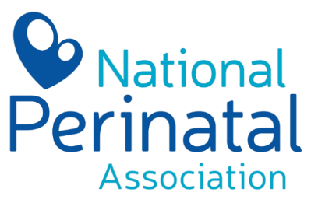
PERINATAL CHOICES and CHALLENGES
Growing and Supporting Families with Joy and Dignity

May 14-16, 2025

Please provide us will the following information:
Please submit this form to klove@nationalperinatal.org by May 1.

Name of Speaker(s):

Email Address(s):
Phone Number: optional

Mailing Address:

Please make the check out to:

Signature:

I would like to donate my honorarium back to NPA and receive a tax donation form.

P.O. Box 392
Lonedell, MO 63060
www.nationalperinatal.org

